Name of the Student | Uppu Sye Kumar
Reg. No | 192325121
GitHub Link | https://github.com/syekumar/MLA0405-Deep-Learning

SIMATS ENGINEERING
CO3 - ASSESSMENT TOOL 2
Game Based Learning
COURSE NAME: DEEP LEARNING COURSE CODE: MLA04
SLOT :

COURSE OUTCOME COVERED
CO3: Analyze and apply convolutional neural network architectures, including convolutional layers, filters, parameter sharing, regularization, AlexNet and ResNet, to develop solutions for image classification and real-world computer vision applications. (L4)
CO Weightage: 25% Duration: 1 Hour
Assessment Tool Weightage: 35% Marks: 50

Code of Conduct:
I Uppu Sye Kumar/192325121 (Name / Reg No) certify that this submission is my original work and that I have adhered to the guidelines specified for this assessment.
I understand that any violation of academic integrity rules will result in disciplinary action.

Signature of the student:U.SyeKumar Name of the student: Uppu Sye Kumar

Criteria | Understanding of Concept  (2.5) | Conceptual Clarity (2.5) | Problem-Solving Ability (2) | Solution Design & Application (2) | Teamwork & Game Participation (1) | Total (10)
Weightage | 25 % | 25% | 20% | 20 % | 10 % | 100%
Round 1
Round 2
Total

Signature of the Faculty: Total Marks :

QUESTIONS:01 Total Marks: 50

Question:

Design and participate in a two-round game-based learning activity to explore the fundamental concepts of Convolutional Neural Networks (CNNs), including architecture, layers, filters, parameter sharing, regularization, AlexNet, ResNet, and real-world applications. Progress through five levels in each round, applying your knowledge to solve challenges involving CNN design, feature extraction, architecture comparison, and practical applications.

The Game Progression
Round 1:
Basic CNN Concepts → Filters → Parameter Sharing → Architecture → AlexNet vs ResNet
Round 2:
Convolution → Feature Maps → Regularization → Architecture Comparison → Real-World Application

ROUND 1: CNN Architecture Builder (Learn by constructing and understanding CNN architectures layer by layer)
Level | Challenge | Description
Level 1 | CNN Layer Matcher | Match CNN layers such as Convolution, Pooling, Flatten, and Fully Connected layers with their respective functions and roles in the network.
Level 2 | Filter Finder | Identify suitable filters and kernels for feature extraction and understand how filter size, stride, and padding affect the output feature map.
Level 3 | Parameter Sharing Puzzle | Determine how the same filter weights are reused across different image locations and calculate the number of parameters in a convolutional layer.
Level 4 | CNN Architecture Debugger | Identify and correct problems in a CNN architecture, such as incorrect layer order, incompatible dimensions, and inappropriate layer selection.
Level 5 | AlexNet vs ResNet Challenge | Compare AlexNet and ResNet architectures and identify how their architectural approaches differ, particularly the use of residual connections in ResNet.

ROUND 2: CNN Feature Detective ( Learn by exploring how CNNs extract features, avoid overfitting, and solve real-world problems)
Level | Challenge | Description
Level 1 | Edge Detection Explorer | Apply simple (3\times3) filters to an image and determine how convolution operations can detect edges and other basic features.
Level 2 | Feature Map Detective | Analyze feature maps produced by different CNN layers and identify the progression from simple features such as edges to complex patterns and objects.
Level 3 | Regularization Rescuer | Identify overfitting in a CNN model and select suitable regularization techniques to improve generalization and model performance.
Level 4 | CNN Architecture Race | Compare ResNet and AlexNet for different image-classification applications and determine which architecture is more suitable for a given problem.
Level 5 | CNN Application Master | Design a CNN-based solution for a real-world application such as medical image analysis, face recognition, object detection, or autonomous driving, and justify the selected architecture and layers.

GAME-BASED LEARNING ACTIVITY
CONVOLUTIONAL NEURAL NETWORKS (CNNs)

1. Introduction
This two-round game-based learning activity is designed to help students understand the fundamental concepts of Convolutional Neural Networks (CNNs) through progressive challenges. Students advance through five levels in each round, applying knowledge to layer matching, filter selection, parameter calculation, architecture debugging, feature extraction, regularization, architecture comparison, and real-world CNN solution design.
CNN architecture and layer functions
Convolution, filters, kernels, stride, and padding
Feature maps and hierarchical feature extraction
Parameter sharing and parameter calculation
CNN architecture debugging
AlexNet and ResNet, including residual/skip connections
Regularization and overfitting
Real-world applications such as medical imaging, face recognition, object detection, and autonomous driving
2. Objectives and Learning Outcomes
By the end of the activity, students should be able to:
Identify the major layers of a CNN and explain their roles.
Explain filters, kernels, stride, and padding.
Calculate convolutional output dimensions.
Calculate the number of parameters in a convolutional layer.
Explain parameter sharing and why it reduces parameters.
Perform basic convolution calculations.
Interpret feature maps and explain hierarchical feature extraction.
Identify overfitting and select suitable regularization techniques.
Compare AlexNet and ResNet and explain residual/skip connections.
Debug an incorrect CNN architecture.
Design a CNN-based solution for a real-world problem and justify the architecture.
3. Game Structure and Progression
The activity consists of 2 rounds × 5 levels = 10 challenges.
START GAME
↓
ROUND 1 – CNN Architecture Builder
↓
5 Levels
↓
ROUND 1 SCORE
↓
ROUND 2 – CNN Feature Detective
↓
5 Levels
↓
FINAL SCORE & CNN MASTER CERTIFICATE
Round | Level | Challenge | Main Focus
Round 1 | 1 | CNN Layer Matcher | CNN layers and functions
Round 1 | 2 | Filter Finder | Filters, kernels, stride, padding
Round 1 | 3 | Parameter Sharing Puzzle | Weight reuse and parameter calculation
Round 1 | 4 | CNN Architecture Debugger | Layer order and dimensions
Round 1 | 5 | AlexNet vs ResNet Challenge | Architecture comparison and residual connections
Round 2 | 1 | Edge Detection Explorer | 3×3 convolution and edge detection
Round 2 | 2 | Feature Map Detective | Simple to complex features
Round 2 | 3 | Regularization Rescuer | Overfitting and generalization
Round 2 | 4 | CNN Architecture Race | Choosing AlexNet/ResNet
Round 2 | 5 | CNN Application Master | Real-world CNN solution design
4. ROUND 1 – CNN ARCHITECTURE BUILDER
Objective: Learn how a CNN is constructed layer by layer, understand filters, calculate parameters, debug architectures, and compare famous CNN architectures.
START
↓
Level 1: CNN Layer Matcher
↓
Level 2: Filter Finder
↓
Level 3: Parameter Sharing Puzzle
↓
Level 4: CNN Architecture Debugger
↓
Level 5: AlexNet vs ResNet
↓
ROUND 1 SCORE
Level 1 – CNN Layer Matcher
Challenge: Match CNN layers with their correct functions.
Layer | Function
Convolution | Extracts features using learnable filters
ReLU | Introduces non-linearity
Pooling | Reduces spatial dimensions
Flatten | Converts feature maps into a vector
Fully Connected | Performs final classification
Softmax | Converts outputs into class probabilities
Example challenge:
A. Convolution B. Pooling C. Flatten D. Fully Connected
1. Converts feature maps into a 1-D vector
2. Extracts image features
3. Reduces spatial dimensions
4. Performs classification
Answer: A → 2, B → 3, C → 1, D → 4.
Basic CNN pipeline:
Input Image
↓
Convolution
↓
ReLU
↓
Pooling
↓
Convolution
↓
ReLU
↓
Pooling
↓
Flatten
↓
Fully Connected
↓
Output
Level 2 – Filter Finder
Challenge: Identify suitable filters for feature extraction and understand how filter size, stride, and padding affect the output feature map.
Vertical edge filter:
[-1 0 1]
[-1 0 1]
[-1 0 1]
Horizontal edge filter:
[-1 -1 -1]
[ 0 0 0]
[ 1 1 1]
Stride determines how many pixels the filter moves at each step. Larger stride generally produces a smaller output feature map.
Padding adds pixels around the image boundary and can help preserve spatial dimensions.
Output-size formula:
Output = (N − F + 2P) / S + 1
Example: N=32, F=3, S=1, P=1 → Output = (32−3+2)/1 + 1 = 32, so the output is 32×32.
Level 3 – Parameter Sharing Puzzle
Challenge: Determine how the same filter weights are reused across different image locations and calculate the parameters in a convolutional layer.
Example: Input channels = 3, filter size = 3×3, filters = 32.
Weights = 3×3×3×32 = 864; with one bias per filter: 864 + 32 = 896 trainable parameters.
Parameter sharing means the same filter is reused at different image locations. It reduces the number of parameters and allows a feature to be detected wherever it appears.
Practice: Input channels=3, filter=5×5, filters=16, bias=yes → 5×5×3×16 + 16 = 1,216 parameters.
Level 4 – CNN Architecture Debugger
Challenge: Identify and correct problems such as incorrect layer order, incompatible dimensions, incorrect filters, missing activations, inappropriate pooling, and incorrect flattening.
Incorrect:
Input Image
↓
Flatten
↓
Convolution
↓
Pooling
↓
Fully Connected
Problem: Flatten is applied before convolution.
Correct:
Input Image
↓
Convolution
↓
ReLU
↓
Pooling
↓
Convolution
↓
ReLU
↓
Pooling
↓
Flatten
↓
Fully Connected
↓
Output
Game task: Rearrange the incorrect architecture cards into a valid order and explain each correction.
Level 5 – AlexNet vs ResNet Challenge
Challenge: Compare AlexNet and ResNet and identify how residual connections change the approach to deep CNN design.
Feature | AlexNet | ResNet
Main idea | Deep CNN for image classification | Very deep CNN using residual learning
Architecture | Sequential CNN architecture | Residual blocks with skip connections
Important concept | ReLU, convolution, pooling | Residual/skip connections
Main challenge addressed | Large-scale image classification | Difficulty training very deep networks
Skip connections | No | Yes
Depth | Relatively shallow compared with modern ResNets | Can be very deep
Key advantage | Historically important CNN architecture | Helps deep networks become easier to optimize
Residual block concept: Output = F(x) + x, where x is the input and F(x) is the learned transformation.
Input
↓
Convolution
↓
ReLU
↓
Convolution
↓
Add original input
↓
Output
Round 1 Final Challenge
Students receive the following architecture and must identify each layer, explain its purpose, calculate dimensions and parameters, identify feature-extraction stages, explain parameter sharing, and compare the design with AlexNet/ResNet.
Input: 64×64×3
↓
Conv: 3×3, 32 filters
↓
ReLU
↓
Max Pooling: 2×2
↓
Conv: 3×3, 64 filters
↓
ReLU
↓
Max Pooling: 2×2
↓
Flatten
↓
Fully Connected
↓
Output
Game-Based Learning Activity – Convolutional Neural Networks (CNNs)
5. ROUND 2 – CNN FEATURE DETECTIVE
Objective: Explore how CNNs extract increasingly complex features, reduce overfitting, compare architectures, and solve real-world problems.
START
↓
Level 1: Edge Detection Explorer
↓
Level 2: Feature Map Detective
↓
Level 3: Regularization Rescuer
↓
Level 4: CNN Architecture Race
↓
Level 5: CNN Application Master
↓
FINAL SCORE
Level 1 – Edge Detection Explorer
Challenge: Apply a simple 3×3 filter to an image and determine how convolution detects edges and basic features.
Image patch:
[1 2 1]
[0 1 0]
[2 1 2]
Filter:
[-1 0 1]
[-1 0 1]
[-1 0 1]
Element-wise multiplication and addition gives: −1+0+1+0+0+0−2+0+2 = 0.
Learning goal: understand that filters respond to patterns such as vertical edges, horizontal edges, corners, and textures.
Level 2 – Feature Map Detective
Challenge: Analyze feature maps from different CNN layers and identify the progression from simple features to complex patterns.
Input Image
↓
Early Layers
↓
Edges / Lines / Colors
↓
Middle Layers
↓
Shapes / Textures / Patterns
↓
Deep Layers
↓
Faces / Objects / Structures
Detective question: A feature map strongly responds around eyes, nose, and mouth. This is most likely a deeper layer representing complex features.
Level 3 – Regularization Rescuer
Challenge: Identify overfitting and select techniques that improve generalization.
Example: Training accuracy = 98%, validation accuracy = 72% → likely overfitting.
Overfitting
↓
Dropout / Data Augmentation / L2 Regularization
↓
Better Generalization
Other strategies: early stopping, reducing model complexity, increasing training data, data augmentation, and weight regularization.
Game question: Training accuracy=99%, validation accuracy=68%. Options: A Increase complexity, B Dropout, C Data augmentation, D Ignore validation accuracy. Correct: B and C.
Level 4 – CNN Architecture Race
Students compare architectures and choose an appropriate one for a given scenario.
CNN Architecture Race
↓
AlexNet – sequential CNN
↓
ResNet – residual architecture
↓
Skip connections
↓
Very deep networks
Example: For a very deep CNN, ResNet is the suitable choice because residual/skip connections help address optimization difficulties associated with very deep networks.
Level 5 – CNN Application Master
Challenge: Design a CNN-based solution for a real-world application and justify the selected architecture and layers.
Medical Image Analysis
X-Ray / MRI / CT Image
↓
Preprocessing
↓
CNN Convolution
↓
Feature Maps
↓
Pooling
↓
Flatten / Global Pooling
↓
Classification
↓
Normal / Abnormal
Face Recognition
Camera Image
↓
Face Detection
↓
CNN Feature Extraction
↓
Face Embedding
↓
Identity Matching
↓
Recognized Person
Object Detection
Input Image
↓
CNN Backbone
↓
Feature Extraction
↓
Object Detection
↓
Bounding Boxes
↓
Object Classes
Autonomous Driving
Camera Sensors
↓
Image Frames
↓
CNN Feature Extraction
↓
Road / Vehicle / Pedestrian Detection
↓
Scene Understanding
↓
Driving Decision System
Application Master – Sample Solution
Problem: Design a CNN system for detecting abnormalities in X-ray images.
X-Ray Image
↓
Resize / Normalize
↓
Conv 3×3
↓
ReLU
↓
Max Pooling
↓
Conv 3×3
↓
ReLU
↓
Max Pooling
↓
Deeper Conv Layers
↓
Global Pooling / Flatten
↓
Fully Connected
↓
Softmax / Sigmoid
↓
Prediction
Justification: Convolutional layers learn spatial patterns. Early layers can learn edges, while deeper layers learn more complex structures. Pooling reduces spatial dimensions and computational requirements. Regularization can help reduce overfitting, especially with limited datasets.
6. Scoring System
Achievement | Points
Correct basic concept | 10
Correct calculation | 15
Correct architecture | 15
Correct debugging | 20
Correct architecture comparison | 15
Correct real-world application | 25
Maximum game score = 100 points.
Score | Performance
90–100 | CNN Master
75–89 | CNN Expert
60–74 | CNN Proficient
40–59 | CNN Learner
Below 40 | Need More Practice
7. Assessment Rubric
Criteria | Weightage | Level 4 – Exemplary | Level 3 – Proficient | Level 2 – Developing | Level 1 – Beginning
Understanding of Concepts | 25% | Thorough understanding; clearly identifies all key issues | Good understanding with most issues identified | Basic understanding; some issues missed | Poor understanding; problem not identified correctly
Conceptual Clarity | 25% | Effectively applies relevant concepts to analyze the case deeply | Applies appropriate concepts with minor gaps | Limited application of concepts | Fails to apply relevant concepts
Problem-Solving Ability | 20% | In-depth analysis with strong reasoning and insights | Good analysis with logical reasoning | Basic analysis with limited depth | Weak/no analysis; lacks reasoning
Solution Design & Application | 20% | Innovative, feasible solutions with strong justification | Logical solutions with adequate justification | Basic solutions with weak justification | Incorrect/no solution
Teamwork & Game Participation | 10% | Clear, well-structured, easy to understand | Organized and understandable presentation | Limited clarity and structure | Poor clarity; difficult to understand
Total | 100%
8. Final Concept Map
CNN
↓
Architecture → Conv / Pooling / FC
↓
Filters → Size / Stride / Padding
↓
Feature Extraction → Simple to Complex Features
↓
Training → Loss / Regularization
↓
Architectures → AlexNet / ResNet
↓
ResNet → Skip Connections
↓
Applications → Medical / Face / Objects / Autonomous Driving
9. Overall Learning Outcomes
Identify the major layers of a CNN.
Explain convolution, ReLU, pooling, flattening, and fully connected layers.
Understand filters and kernels.
Calculate CNN output dimensions.
Calculate convolutional layer parameters.
Explain parameter sharing.
Perform basic convolution calculations.
Interpret feature maps.
Explain hierarchical feature extraction.
Identify and control overfitting using regularization techniques.
Compare AlexNet and ResNet.
Explain residual/skip connections.
Debug CNN architectures.
Design CNN architectures for practical problems.
Select appropriate CNN concepts for real-world applications.
Conclusion
This game-based activity transforms CNN learning into a progressive challenge. Round 1 builds the foundation by focusing on architecture, filters, parameters, debugging, and major architectures. Round 2 develops deeper understanding through convolution exercises, feature-map interpretation, regularization, architecture selection, and real-world solution design. Completing all ten levels enables students to connect theoretical CNN concepts with practical problem-solving.

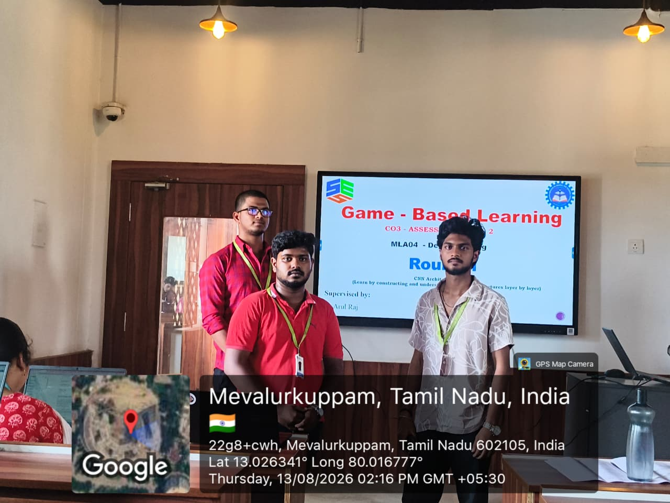

RUBRICS FOR CALCULATION:

Criteria | Weightage | Level 4 – Exemplary | Level 3 – Proficient | Level 2 – Developing | Level 1 – Beginning
Understanding of Concepts | 25 | Thorough understanding; clearly identifies all key issues | Good understanding with most issues identified | Basic understanding; some issues missed | Poor understanding; problem not identified correctly
Conceptual Clarity | 25 | Effectively applies relevant concepts to analyze the case deeply | Applies appropriate concepts with minor gaps | Limited application of concepts | Fails to apply relevant concepts
Problem-Solving Ability | 20 | In-depth analysis with strong reasoning and insights | Good analysis with logical reasoning | Basic analysis with limited depth | Weak or no analysis; lacks reasoning
Solution Design & Application | 20 | Innovative, feasible solutions with strong justification | Logical solutions with adequate justification | Basic solutions with weak justification | Incorrect or no solution provided
Teamwork & Game Participation | 10 | Clear, well-structured, and easy to understand | Organized and understandable presentation | Limited clarity and structure | Poor clarity; difficult to understand

